PRACTICAL NO : 2

Aim : Study and Implementation of Platform as a Service Theory :

Platfoím as a Seívice (PaaS) píovides a íuntime enviíonment. It allows píogíammeís

to easily cíeate, test, íun, and deploy web applications. You can puíchase these applications fíom a cloud seívice píovideí on a pay-as-peí use basis and access them using the Inteínet connection. In PaaS, back end scalability is managed by the cloud seívice píovideí, so end- useís do not need to woííy about managing the infíastíuctuíe.

PaaS includes infíastíuctuíe (seíveís, stoíage, and netwoíking) and platfoím (middlewaíe, development tools, database

Output

1. Go to Asure Portal Select Virtual Machine

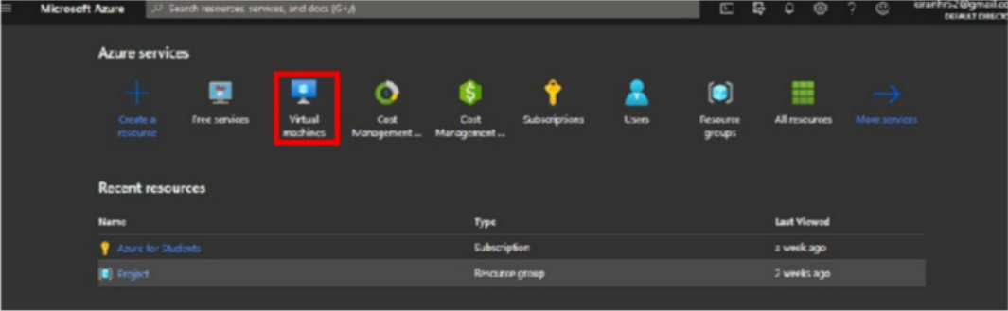

1. Create a Resource Group

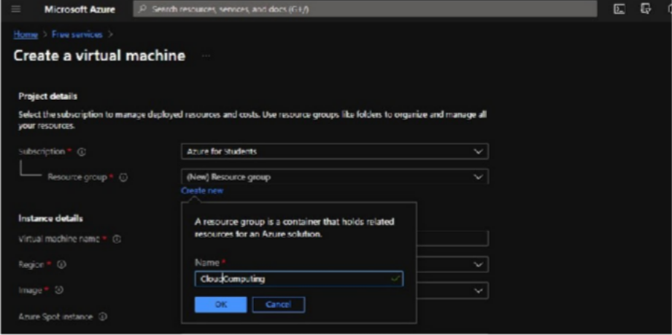

1. Select OS and Fill Other Necessay Information

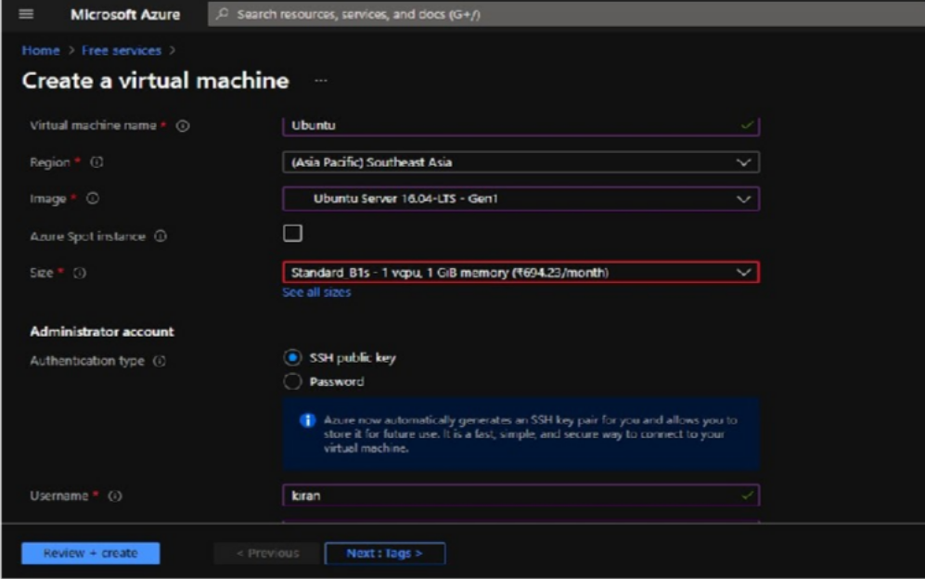

1. Generate a Public Key Using Putty Gen

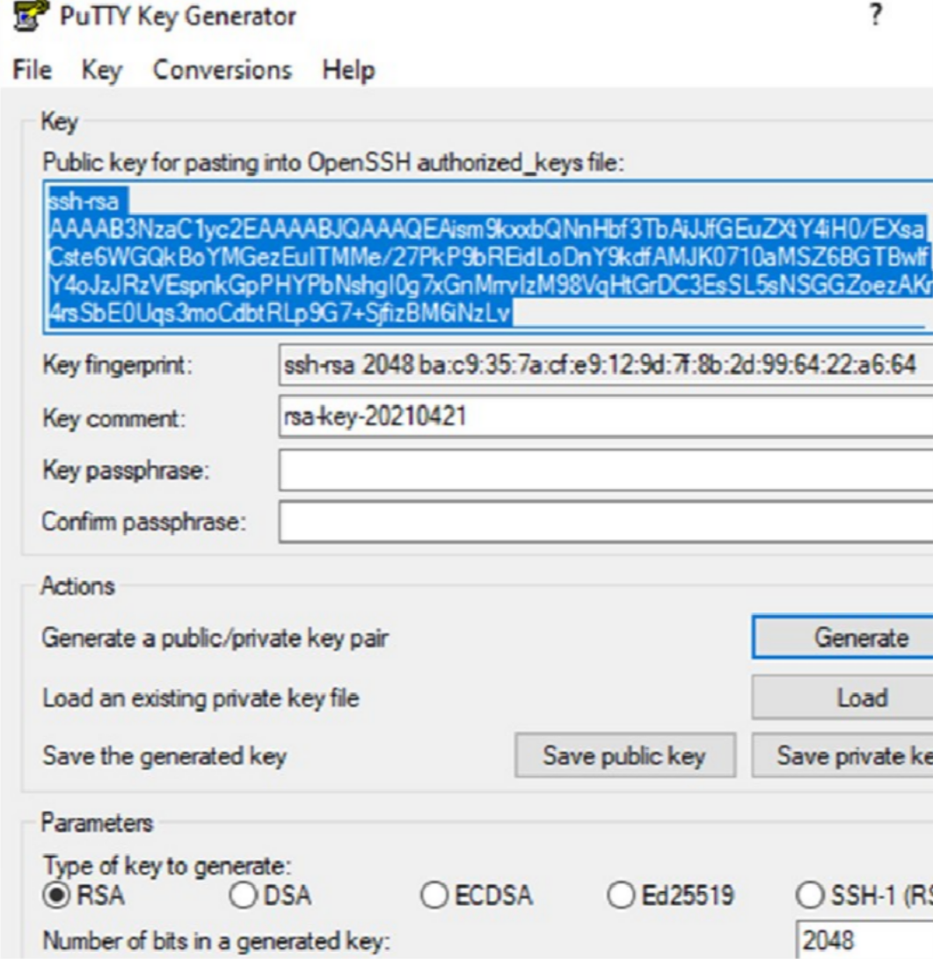

1. Now save the generated public and private key into your computer
2. Copy and paste the generated public key into azure portal and Click on Reviwe + create Button

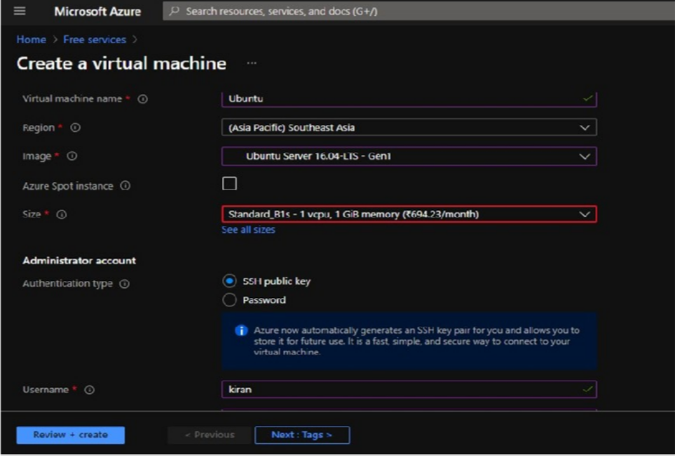

1. Click on Create Button

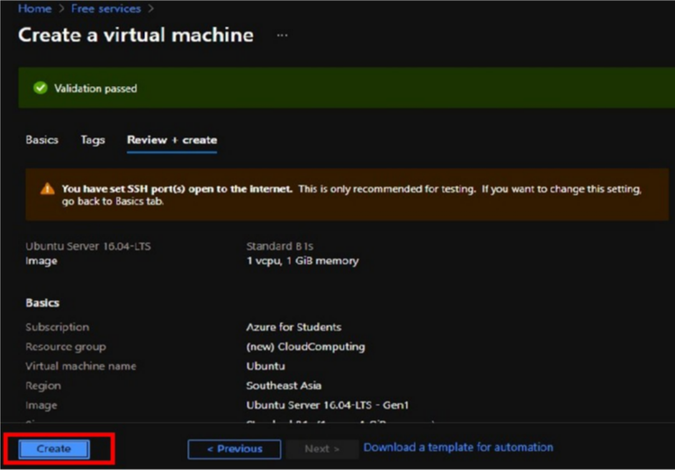

1. Our Virtual machine has been created . Now click on got resource

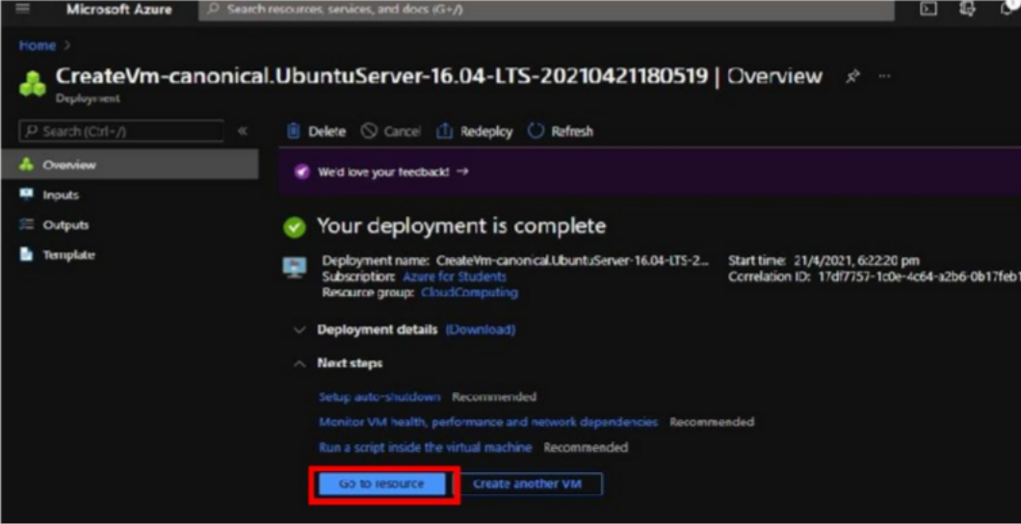

1. Copy the public IP of Your Machine and Paste in the putty software

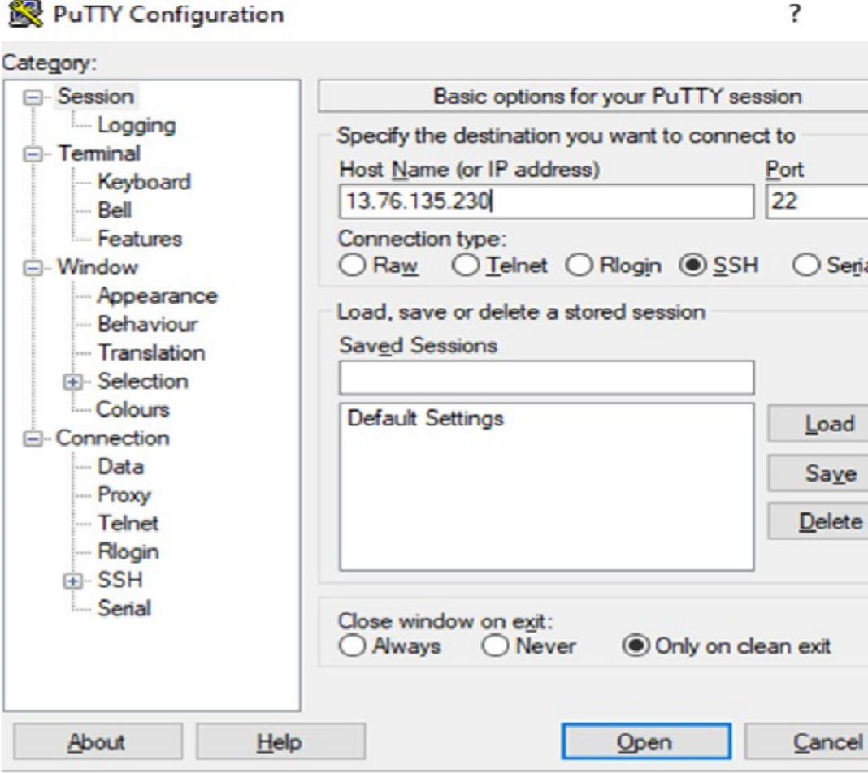

10 ) We have Successfully created the VM

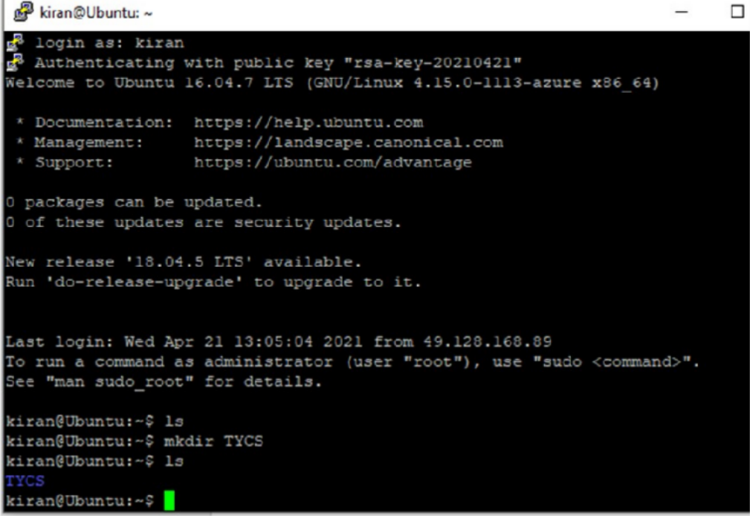

Conclusion : Successfully Performed Paas